268-[DF]-Lab - Database Table Operations

269-[DF]-Lab - Insert, Update, and Delete Data in a Database

270-[DF]-Lab - Selecting Data from a Database

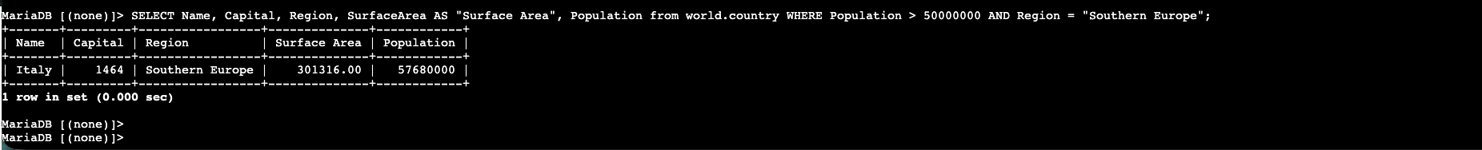

**Performing a Conditional Search**

**Working with Functions**

**Organizing Data**

**Build Your DB Server and Interact With Your DB Using an App**

**Introduction to Amazon Aurora**

**Introduction to Amazon DynamoDB**

Database challenge task

**Install and Configure the AWS CLI**

